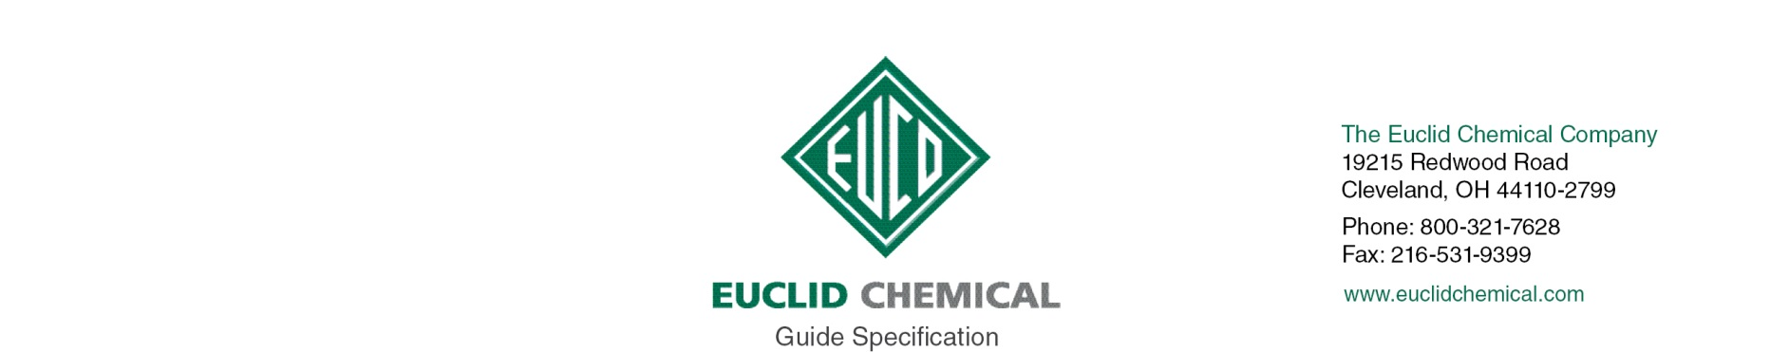
SUPER DIAMOND CLEAR
Non-Yellowing Curing and Sealing Compound

SUPER DIAMOND CLEAR is a solvent based curing and sealing compound specially designed to cure new concrete, assuring proper cement hydration and strength gain, while providing a non-yellowing seal to protect and enhance the appearance of concrete. This product is suitable for use on interior and exterior concrete surfaces.

{Note to Specifier: The paragraphs below are meant to be incorporated into Parts 2 and 3 of a standard CSI 3 Part Format specification, project’s General Structural Notes or directly onto the plans. They must be carefully reviewed by a qualified design professional and edited to meet the particular requirements of the project at hand, assure compliance with any governing building codes, and coordinate with other specification sections and drawings.}

PART 2: PRODUCT

2.__CURING AND SEALING COMPOUND

A. Concrete curing and sealing compound. A ready-to-use, acrylic curing and sealing compound for use on new and existing, interior and exterior, horizontal and vertical concrete surfaces. Product shall conform to:
ASTM C 309, Type 1 Class A & B and ASTM C 1315 Type 1 Class A.
AASHTO Specification M 148, Type 1, Class A & B
1. Product:
- Euclid Chemical Company (The); Super Diamond Clear www.euclidchemical.com

2.__ Manufacturer shall have ISO 9001 Quality Certification.

PART 3: EXECUTION

3.__ EXAMINATION

A. When used on existing concrete, examine concrete surfaces to receive curing and sealing compound. Notify specifier if surfaces are not acceptable. Do not begin surface preparation or application until unacceptable conditions are corrected.

3.__ SURFACE PREPARATION

A. When used on existing concrete, prepare concrete surfaces in accordance with manufacturer’s written instructions.

B. Ensure surfaces are clean and free of standing water.

C. Remove dirt, dust, oil, grease, sealers, and other materials that may prevent adhesion of curing and sealing compound.

3.__ APPLICATION

A. For the best cure of freshly placed concrete, apply SUPER DIAMOND CLEAR as soon as possible after finishing operations and/or immediately after the disappearance of the “sheen” of surface moisture.

B. Apply curing and sealing compound to concrete surfaces in accordance with manufacturer’s written instructions.

C. Apply compound at uniform coverage rate in accordance with manufacturer’s written instructions.

D. Apply as soon as possible after finishing and immediately after disappearance of surface moisture sheen, when used to cure freshly placed concrete.

E. Do not apply to concrete to receive toppings, epoxy coatings, urethane coatings, or epoxy adhesives.

F. Do not use as a bond breaker for tilt-up construction.

G. Do not dilute curing and sealing compound.

H. Cure concrete surfaces as specified in Section 03300.

