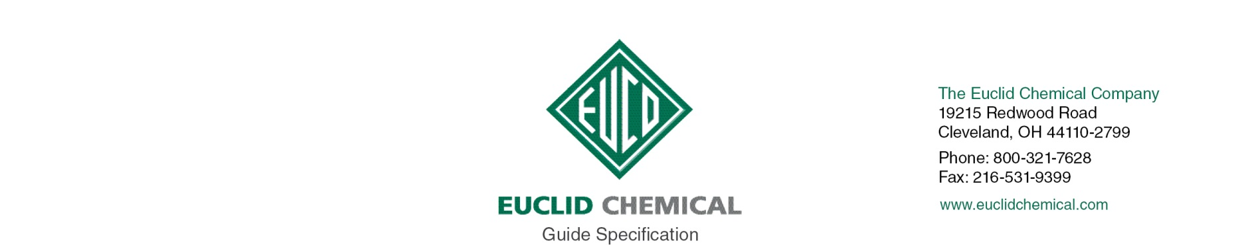

BARACADE SILANE 40 IPA
ISOPROPYL ALCOHOL-BASED SILANE WATER REPELLENT

Note: The paragraphs below are meant to be incorporated into Parts 2 and 3 of a standard CSI 3 Part Format specification, the General Structural Notes, or directly onto the plans. They must be carefully reviewed by a qualified design professional and edited to meet the requirements of the project and governing building codes. Coordinate with other specification sections and drawings. In no case shall these Guide Specifications be considered to be Contract Documents or serve as installation instructions for the product being discussed. In any cases of discrepancy the manufacturer's most recently published data sheet shall take precedent.

SECTION 07 19 00 WATER REPELLENTS

PART 1: GENERAL

1.01 JOB SITE CONDITIONS

A. Material shall be stored at temperatures between 40 and 85 deg F. Protect from moisture, direct sunlight and freezing.

B. Do not apply Penetrating Water Repellent Sealer to frost filled surfaces or when temperature is below 20 deg. F.

C. Do not apply Penetrating Water Repellent Sealer if rain is expected within 4 to 6 hours.

PART 2.0 PRODUCT

2.01 PENETRATING WATER REPELLENT SEALER

A. Penetrating Water Repellent: Clear penetrating, isopropyl alcohol-based, sealer containing of 40 percent silane and meeting the following criteria;

1. Basis of Design Product: Euclid Chemical Company (The): Baracade Silane 40 IPA www.euclidchemical.com

a. Flash Point: 54 Deg F.
b. Resistance to UV excellent
c. NCHRP No. 244 Series II: 93 percent Reduction in Chloride Content
d. NCHRP No. 244 Series II: 93 percent Reduction in water absorption
e. NCHRP No. 244 Series IV: 89 percent Reduction in Chloride Ion Content
f. VOC’s 580 g/l

B. Manufacturer shall have ISO 9001 Quality Certification.

PART 3.0 EXECUTION

3.01 SURFACE PREPARATION

A. New concrete surfaces must be a minimum 7 days old at time of application.

B. Surface shall be structurally sound, clean, dry, free of dust, dirt, paint, efflorescence, laitance curing compounds and other contaminants that will prevent the proper penetration of penetrating water repellent.

Note to Specifier: Prior to application of penetrating sealer all joints and cracks should be properly sealed against moisture intrusion. Insert appropriate section number below.

C. Prior to application, joints or cracks must be properly sealed in accordance with Section <<insert section>>

D. If acid is used for cleaning, neutralize completely before application of penetrating water repellent.

E. Surfaces must dry a minimum of 24 hours following rain or exposure to other sources of moisture

3.02 PENETRATING WATER REPELLENT APPLICATION:

Note to Specifier: Insert desired number of coats.

A. Apply [1][2] coat[s] per manufacturer’s recommendations utilizing low pressure airless spray equipment.
1. Actual coverage and number of coats to be determined by field test sample application and water absorption testing. Final approval by architect/engineer is required.
2. Where a second coat is required it shall be applied “wet on wet” before the first coat dries.

B. Do not allow material to puddle. Remove excess material with squeegee or broom.

END OF SECTION

