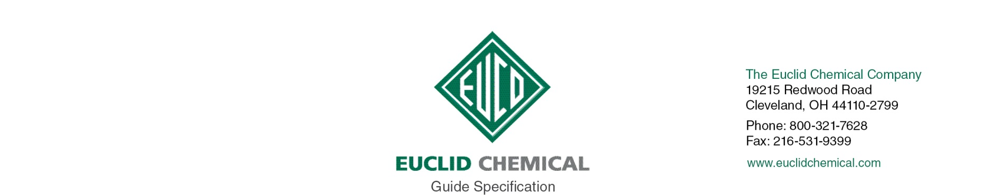

BARACADE SILANE 100 C
100% Penetrating Silane Treatment for Concrete and Masonry

Note: The paragraphs below are meant to be incorporated into Parts 2 and 3 of a standard CSI 3 Part Format specification, the General Structural Notes, or directly onto the plans. They must be carefully reviewed by a qualified design professional and edited to meet the requirements of the project and governing building codes. Coordinate with other specification sections and drawings. In no case shall these Guide Specifications be considered to be Contract Documents or serve as installation instructions for the product being discussed. In any cases of discrepancy the manufacturer's most recently published data sheet shall take precedent.

SECTION 07 19 00 WATER REPELLENTS

PART 1: GENERAL

1.02 JOB SITE CONDITIONS

A. Material shall be stored at temperatures below 90 deg F.

B. Do not apply Penetrating Water Repellent Sealer to frost filled surfaces or when ambient or surface temperatures are below 20 deg F.

C. Do not apply Penetrating Water Repellent Sealer if rain is expected within 4 to 6 hours.

PART 2.0 PRODUCT

2.01 PENETRATING WATER REPELLENT SEALER

A. Penetrating Water Repellent: Clear penetrating sealer consisting of 100 percent silane and meeting the following criteria;

1. Basis of Design Product: Euclid Chemical Company (The): Baracade Silane 100 C www.euclidchemical.com

Flash Point | 154 Deg F (67.8 Deg C).
Depth of Penetration | 0.30 inches (7.6 mm)
Dry Time Foot and Wheel Traffic | 2 to 4 hours
NCHRP 244, Series II, Reduction in Water Absorption | 93 percent
NCHRP 244 Series II, Reduction in Chloride Ion Content | 90 percent
NCHRP 244 Series IV (Southern Exposure) Accelerated Weathering | No Change
NCHRP 244 Series IV (Southern Exposure) Reduction In Chloride Ion Content | 95 percent
NCHRP 244 Series IV (Northern Exposure) Accelerated Weathering | No Change
NCHRP 244 Series IV (Northern Exposure) Reduction in Chloride Ion Content | 91 percent
AASHTO T259 & T260 Resistance to Chloride Ion Penetration | 85 percent reduction in absorbed chloride 1/16 to ½ inch depth  97 percent reduction in absorbed chloride ½ to 1 inch depth
ASTM E514 Water Penetration Reduction CMU | 91.4 percent
ASTM C642 Absorption Reduction | 93.3 percent
Fed Spec SS-W-110C – Water Repellency | 0.53 percent water absorption
Fed Spec SS-W-110C – Weathering | 0.60 percent water absorption
Fed Spec SS-W-110C - Efflorescence Resistance | No visible efflorescence
ASTM E96 Water Vapor Transmission | 96 percent (2 percent reduction versus control)

B. Manufacturer shall have ISO 9001 Quality Certification.

PART 3.0 EXECUTION

3.01 SURFACE PREPARATION

A. New concrete surfaces must be a minimum 7 days old at time of application.

B. Surface shall be structurally sound, clean, dry, free of dust, dirt, paint, efflorescence, laitance curing compounds and other contaminants that will prevent the proper penetration of penetrating water repellent.

Note to Specifier: Prior to application of penetrating sealer all joints and cracks should be properly sealed against moisture intrusion. Insert appropriate section number below.

C. Prior to application, joints or cracks must be properly sealed in accordance with Section <<insert section>>

D. If acid is used for cleaning, neutralize completely before application of penetrating water repellent.

E. Surfaces must dry a minimum of 24 hours following rain or exposure to other sources of moisture.

3.02 PENETRATING WATER REPELLENT APPLICATION:

Note to Specifier: Insert desired number of coats.

A. Apply [1][2] coat[s] per manufacturer’s recommendations utilizing low pressure airless spray equipment.
1. Actual coverage and number of coats to be determined by field test sample application and water absorption testing. Final approval by architect/engineer is required.
2. Where a second coat is required it shall be applied “wet on wet” before the first coat dries.

B. Do not allow material to puddle. Remove excess material with squeegee or broom.

END OF SECTION

