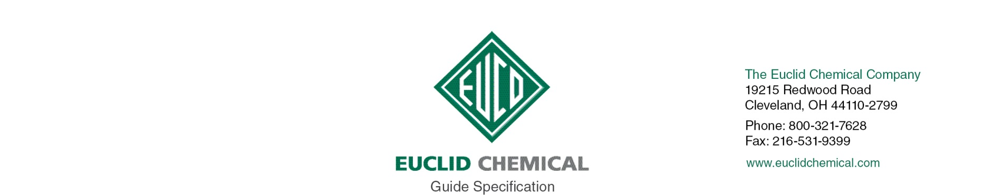

CHEMSTOP WB HEAVY DUTY

Water Based Silane/Siloxane Penetrating Water Repellent Sealer for Porous Masonry and Concrete Surfaces.

Note: The paragraphs below are meant to be incorporated into Parts 2 and 3 of a standard CSI 3 Part Format specification, the General Structural Notes, or directly onto the plans. They must be carefully reviewed by a qualified design professional and edited to meet the requirements of the project and governing building codes. Coordinate with other specification sections and drawings. In no case shall these Guide Specifications be considered to be Contract Documents or serve as installation instructions for the product being discussed. In any cases of discrepancy the manufacturer's most recently published data sheet shall take precedent.

SECTION 07 19 00 WATER REPELLENTS

PART 1: GENERAL

1.02 JOB SITE CONDITIONS

A. Material shall be stored at temperatures between 40 and 90 deg F.

B. Do not apply Penetrating Water Repellent Sealer to frost filled surfaces. Both substrate and ambient temps shall be 45 deg F. and rising at time of application.

C. Do not apply Penetrating Water Repellent at temperatures above 90 deg F.

C. Do not apply Penetrating Water Repellent Sealer if rain is expected within 12 hours.

PART 2.0 PRODUCT

2.01 PENETRATING WATER REPELLENT SEALER

A. Penetrating Water Repellent: Water Based, ready to use, silane/siloxane blend, penetrating, clear water repellant sealer designed for use on porous masonry and concrete surfaces.

1. Basis of Design Product: Euclid Chemical Company (The): Chemstop WB Heavy Duty www.euclidchemical.com1.

a. Viscosity 50 cps
b. SS-W-110C: 92 percent Reduction in Water Absorption
c. VOC’s 50 g/l
d. ASTM E514: 100 percent Reduction in Water Leakage – Brick
e. ASTM E514: 91 percent Reduction in Water Leakage Mortar/Block

B. Manufacturer shall have ISO 9001 Quality Certification.

PART 3.0 EXECUTION

3.01 SURFACE PREPARATION

A. New concrete surfaces must be a minimum 7 days old at time of application.

B. Surface shall be structurally sound, clean, dry, free of dust, dirt, paint, efflorescence, laitance curing compounds and other contaminants that will prevent the proper penetration of penetrating water repellent.

Note to Specifier: Prior to application of penetrating sealer all joints and cracks should be properly sealed against moisture intrusion. Insert appropriate section number below.

C. Prior to application, joints or cracks must be properly sealed in accordance with Section <<insert section>>

D. If acid is used for cleaning, neutralize completely before application of penetrating water repellent.

E. Surfaces must dry a minimum of 24 hours following rain or exposure to other sources of moisture

3.02 PENETRATING WATER REPELLENT APPLICATION:

Note to Specifier: Insert desired number of coats.

A. Apply [1][2] coat[s] per manufacturer’s recommendations utilizing low pressure airless spray equipment.
1. Actual coverage and number of coats to be determined by field test sample application and water absorption testing. Final approval by architect/engineer is required.
2. Where a second coat is required it shall be applied “wet on wet” before the first coat dries.

B. Do not allow material to puddle. Remove excess material with squeegee or broom.

END OF SECTION

