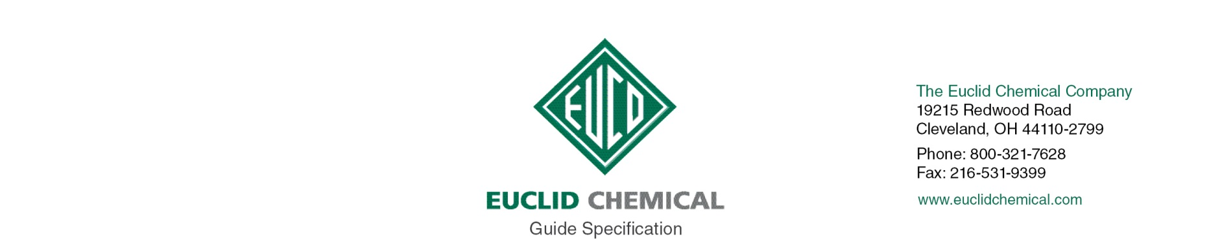
EUCOSIL
Cast-In-Place Concrete
{Note to Specifier: This add-in specification component specifies Euclid Chemical Company, Eucosil Liquid Densifier and Sealer for Concrete}
EUCOSIL is a water based sodium silicate solution used to densify, seal and dustproof concrete
{Note to Specifier: The paragraphs below are meant to be incorporated into Parts 2 and 3 of a standard CSI 3 Part Format specification, project’s General Structural Notes or directly onto the plans. They must be carefully reviewed by a qualified design professional and edited to meet the particular requirements of the project at hand, assure compliance with any governing building codes, and coordinate with other specification sections and drawings.}
      - QUALITY REQUIREMENTS

A. Manufacturer: ISO 9001 quality certified as primary manufacturer of specified products.

      - INFORMATIONAL SUBMITTALS
        - Product List: List manufacturer name and product name for each product proposed for use as concrete admixture and surface treatment.

        - Manufacturer Certificate: Indicating products listed on Contractor's Product List are compatible and suitable for the specified application.

PART 2 - PRODUCTS
      - MANUFACTURERS
        - Manufacturer: Provide listed products of Euclid Chemical Co., Euclid, OH; www.euclidchemical.com.

        - Manufacturer Single Source: Provide liquid densifier compound and related concrete treatment and admixture products from a single qualified manufacturer.
      - LIQUID FLOOR TREATMENTS
        - Liquid Densifier: Penetrating concrete densifier odorless, colorless, VOC - compliant, non-yellowing sodium silicate solution designed to harden, dustproof and protect concrete floors
            - Products
              - Basis of Design Product: Eucosil by The Euclid Chemical Company
- EXECUTION
      - EXAMINATION
{Note to Specifier: Retain this article when applying liquid densifier sealer to existing concrete surfaces.}
        - When used on existing concrete, examine concrete surfaces to receive liquid densifier sealer. Notify specifier if surfaces do not comply with manufacturer's recommendations. Do not begin surface preparation or application until unacceptable conditions are corrected
      - PREPARATION
        - When used on existing concrete, prepare concrete surfaces in accordance with manufacturer’s written instructions.
          - Ensure surfaces are clean, dry and free of standing water.
          - Remove dirt, dust, oil, grease, sealers, and other materials that may prevent penetration liquid densifier sealer.
      - APPLICATION
        - Apply liquid densifier sealer to designated concrete areas in continuous manner following manufacturer’s published recommendations regarding coverage and installation. Brush out all puddles and runs immediately. Do not allow excess material to dry on surface.

