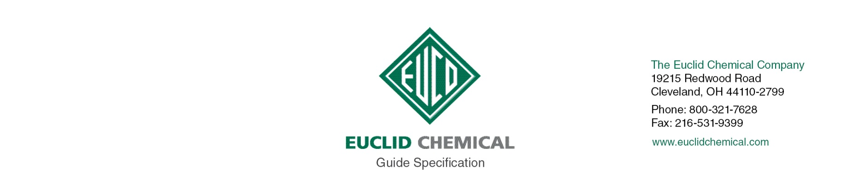
EUCO CLEAN & STRIP
Concrete Floor Stripper

{Note to Specifier: The paragraphs below are meant to be incorporated into Parts 2 and 3 of a standard CSI 3 Part Format specification, the General Structural Notes, or directly onto the plans. They must be carefully reviewed by a qualified design professional and edited to meet the requirements of the project and governing building codes. Coordinate with other specification sections and drawings.}

PART 2: PRODUCT

{Note to Specifier: This section covers Euco Clean and Strip Concrete Floor Stripper. All the material properties shown in the sub paragraphs below are not typically applicable on every project. They are listed here in order to allow the design professional to review and edit the information according to the particular project parameters for which the product will be used.}

{PRODUCT}

2.__ PRODUCT

A. Weight per gallon: 7.0 lbs./gal (0.85 kg/L

B. Flash Point: 117 degrees F (47 degrees C)

C. Odor: Citrus

D. Appearance: Mild citrus smell

E. Product: Euclid Chemical (The); Euco Clean and Strip www.euclidchemical.com

{ISO AND SINGLE SOURCE}

2.__ MANUFACTURER

A. Manufacturer shall have ISO 9001 Quality Certification. To ensure compatibility with all primers, joint sealants shall be from the same manufacturer.

B. The Euclid Chemical Company, 19218 Redwood Road, Cleveland, OH 44110. (800) 321-7628. (216) 531-9222. www.euclidchemical.com.

PART 3: EXECUTION

{PREP}

3.__ SURFACE PREPARATION

A. Refer to manufacturer’s written instructions.

B. Product may be diluted with water before using, depending on the extent of the stripping to be done. Experimenting with different dilution ratios may be necessary to determine which strength is most suitable. Always test a small area before use.

{APPLICATION}

4.__ APPLICATION

A. Apply to floor using sprayers, automatic floor scrubbers, or other conventional methods. Product should remain on the floor for 30 minutes. Redistribute puddles during the soak time. Do not allow the product to dry. Add more product if necessary.

B. After product has been on the floor for the appropriate amount of time, scrub with ride-on or walk behind mechanical scrubbers. After scrubbing, rinse the area with clean water or vacuum until there is no visible trace of product remaining on the floor. If necessary, repeat the process until the desired results are achieved

{CLEANUP}

A. Remove debris related to application of sealants from project site per applicable regulations for hazardous waste disposal.

{PROTECTION}

A. Protect work from contaminating substances and damage resulting from other construction operations or other causes so that sealed joints are without deterioration or damage at time of project completion.

