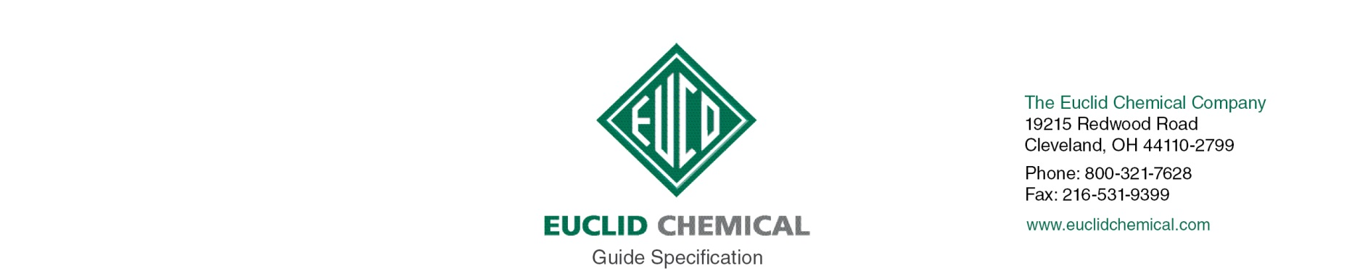
DURALTOP GEL

Vertical and overhead polymer modified, cementitious structural repair mortar containing corrosion inhibitor and designed for placement at thickness from 1/8” to 2” per lift.

{Note to Specifier: The paragraphs below are meant to be incorporated into Parts 2 and 3 of a standard CSI 3 Part Format specification, project’s General Structural Notes or directly onto the plans. They must be carefully reviewed by a qualified design professional and edited to meet the particular requirements of the project at hand, assure compliance with any governing building codes, and coordinate with other specification sections and drawings.}

PART 2.0: PRODUCT

2.__ {Optional} BONDING AGENT/PRIMER

{REPAIR NOTE 1: Optional Bonding Agents}

{Note to Specifier: Certain bonding agents, adhesives and primers can be used to enhance the bond of this repair mortar. If desired choose a recommended bonding agent/primer from the data sheet and insert here. (Note: Latex additives will increase the volumetric resistivity of the mortar making it no longer compatible with Galvanic Anode Protection}

{PRODUCT}

2.__ CEMENTITIOUS REPAIR MORTAR

A. Trowelable vertical and overhead repair mortar for application thicknesses of 1/8” to 2”: Cement-based, one component, polymer modified, fast setting repair mortar, containing migratory corrosion inhibiting admixture and suitable for interior or exterior use, Material shall have the following properties:
1. Compressive Strength minimum per ASTM C 109
4 hours 1,100 psi
1 day 4,000 psi
3 days 6,000 psi
7 days 7,000 psi
28 days 8,000 psi
2. Flexural Strength minimum 2,000 psi at 28 days per ASTM C 293
3. Linear Shrinkage maximum -0.040% 7 days and 0.062% at 28 days per ASTM C 157
4. Shear Bond Strength: minimum 1,000 psi at 3 days per ASTM C 1042

5. Chloride Permeability 160 coulombs “very low” per ASTM C 1202
6. Product:
a) Euclid Chemical Company (The); Duraltop GEL, www.euclidchemical.com

B. Manufacturer shall have ISO 9001 Quality Certification. To ensure compatibility all admixtures shall be from the same manufacturer.
C. To ensure compatibility bonding agent and curing compound if used shall be from same manufacturer as repair mortar.

{REPAIR CURING NOTE 1}

2.___ CURING

{Note to Specifier: Euclid Chemical suggests curing this repair mortar with a high solids curing compound. If desired choose a recommended product from the data sheet and insert here. Guide spec language for these products can be found by accessing each product separately through this web site. Be advised that liquid curing compounds are typically not compatible with future penetrating sealer, adhesives or coatings. If such treatments are intended the specifier should insert language for a dissipating resin curing compound such as KUREZ DR VOX, a removable curing compound such as KUREZ RC, or insert language for proper moisture retaining curing methods meeting ACI 308. Duration of such cure should be minimum 3 days.}

PART 3.0: EXECUTION

3.___ SURFACE PREPARATION

{CONCRETE REMOVAL NOTE}

A. Concrete Removal: Remove all loose and unsound concrete per ICRI Guideline 310.1R “Guide for Surface Preparation”
1. Unsound concrete surface areas shall have perimeter boundaries saw cut to minimum depth of ½” inch or less if such depth will cause saw to come in contact with embedded reinforcing steel. Saw cuts shall be made perpendicular to the concrete surface and all concrete removal boundaries shall be straight and aligned parallel to opposite boundary edges resulting in repair areas that are rectangular in shape.
2. All concrete shall be removed from within repair boundary to minimum depth of ½” inch. Provide a surface with suitable profile for bond, as defined in repair mortar manufacturer’s written recommendations. If delaminations, cracking, or unsound materials exist beyond minimum removal depth, then removal shall continue until all unsound, delaminated, or cracked concrete has been removed from cavity.

{STEEL PREP NOTE 1}

B. Preparing Reinforcing Steel: Clean and prepare any exposed embedded reinforcing steel per ICRI Guideline 310.1R. “Guide for Surface Preparation”
1. Where ½ or more of diameter of reinforcement steel is exposed either by existing conditions or concrete removal, bond between the concrete and reinforcing steel is broken, or corrosion is present, the concrete shall be removed to provide a minimum ¾” clearance around entire perimeter of steel and along entire exposed length.
2. Clean all exposed reinforcing steel to bright steel, prior to installation of repair mortar.
a) Where section loss on a reinforcing bar is more than [insert number]%, or [insert number]% in two or more adjacent bars contact Engineer.
{CONCRETE PREP AND CLEANING NOTE}

C. Concrete Preparation and Cleaning: Areas to receive concrete repair shall be structurally sound and free from deteriorated concrete, dust, dirt, debris, loosened concrete, paint, oil, efflorescence, laitance, and other contaminants, and shall have a minimum Concrete Surface Profile CSP equal to that recommended by the repair mortar manufacturer per ICRI Guideline 310.2.

3.___ REPAIR MORTAR APPLICATION:

{TROWEL APPLIED REPAIR MORTAR APPLICATION}

A. Repair Mortar Trowel Applied: Mix and apply Repair Mortar per manufacturer’s recommendations within the open time of the product scrub coat or any bonding agents. Finish to level of surrounding concrete surface utilizing techniques recommended by manufacturer.

3.___ CURING

{REPAIR MORTAR CURING EXECUTION}

{Note to Specifier: Euclid Chemical suggests curing this repair mortar with a high solids curing compound. If desired choose a recommended product from the data sheet and insert here. Guide spec language for these products can be found by accessing each product separately through this web site. Be advised that liquid curing compounds are typically not compatible with future penetrating sealer, adhesives or coatings. If such treatments are intended the specifier should insert language for a dissipating resin curing compound such as KUREZ DR VOX, a removable curing compound such as KUREZ RC, or insert language for proper moisture retaining curing methods meeting ACI 308. Duration of such cure should be minimum 3 days.}

